NOVA EISENHOWER READING CHALLENGE

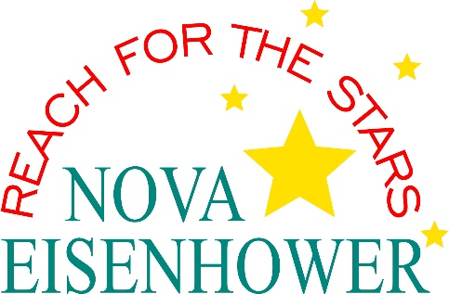

Dear 2021-2022 Kindergarten, First, Second, Third, and Fourth Grade Parents:

We are very excited that as an extension to our reading program, we will be offering a NOVA EISENHOWER READING CHALLENGE during the summer months for your child(ren). We have purchased a book for your child to read and enjoy over the summer. (Your child will receive the book during the last week of school and may keep this book.)

At the start of the 2022-2023 school year, students will participate in activities based on this book. Therefore, it is important that your child reads the book. One of the most successful reading strategies for comprehension is to re-read chapters/portions of the book. This allows students to have a better understanding of the author’s intent.

Please help us encourage students to read books not only as an educational resource, but also for enjoyment. Our goal is to make reading exciting so that your child(ren) will become lifelong readers.

We are asking for a donation to help offset the cost of the books. Whether you can make a donation at this time or not, every child will receive a book.

If you are able to assist us, please go online between May 2, 2022 and May 31, 2022 to donate. Please follow these directions:

*Go online to Novaeisenhower.com
*Click the following
*Students and Parents
*Parents
*Online Payments
*Scroll down and click on Summer Reading Program

Thank you in advance for donating to this wonderful challenge.

